Population Simulator

**Business Requirement:-**

Create a population simulator which estimates the population growth given no of years you want to simulate for

**Functional Specification:-**

### Assumptions

Below assumptions have been made to complete this task.

1. User is required to input length of years for which population growth is to be simulated
2. Population simulator assumes existence of only one baby amoeba in year 1900
3. At the turn of each year, baby amoeba gets added to new population
4. At the turn of each year, existing baby amoeba changes to adult & each of the adults have one baby amoeba
5. Average death rate at the end of each year is assumed to be 0.2% of existing total population

### Solution Description

Step by step description of how population Simulator works

1. User inputs length in terms of years you want to simulate population for
2. User can always see current population (baby & adult amoeba)
3. Upon click on ‘Simulate Growth’ button, system calculates total baby ameobas to be added to new population based on existing adult amoeba population
4. System allows considers fixed % of death rate in adult population & the same would be reduced from total population at the turn of each year

Solution Description

### Technical Overview

**Introduction:-**

This section talks about technical components required to build Population Simulator. Technical components encompasses Data model, Controllers to control what data to show in UI.

**Data Model Design:-**

Below data objects are needed to design solution for Population Simulator.

1. Variable to keep track of what’s the current baby & adult amoeba population
2. Variable to keep track of starting year at which new baby amoeba is added
3. Variable to store intermediate calculated values for the calculation of total baby & adult amoeba for the length of years being simulated

**JavaScript Method:**



Test Results:-

This is how UI home screen looks like. User access this screen to simulate population growth for the length of simulation period selected.

Home screen shows current period population viz., baby amoeba & adult amoeba. User can enter no of years (length of simulation period) to find population growth relative to current year.

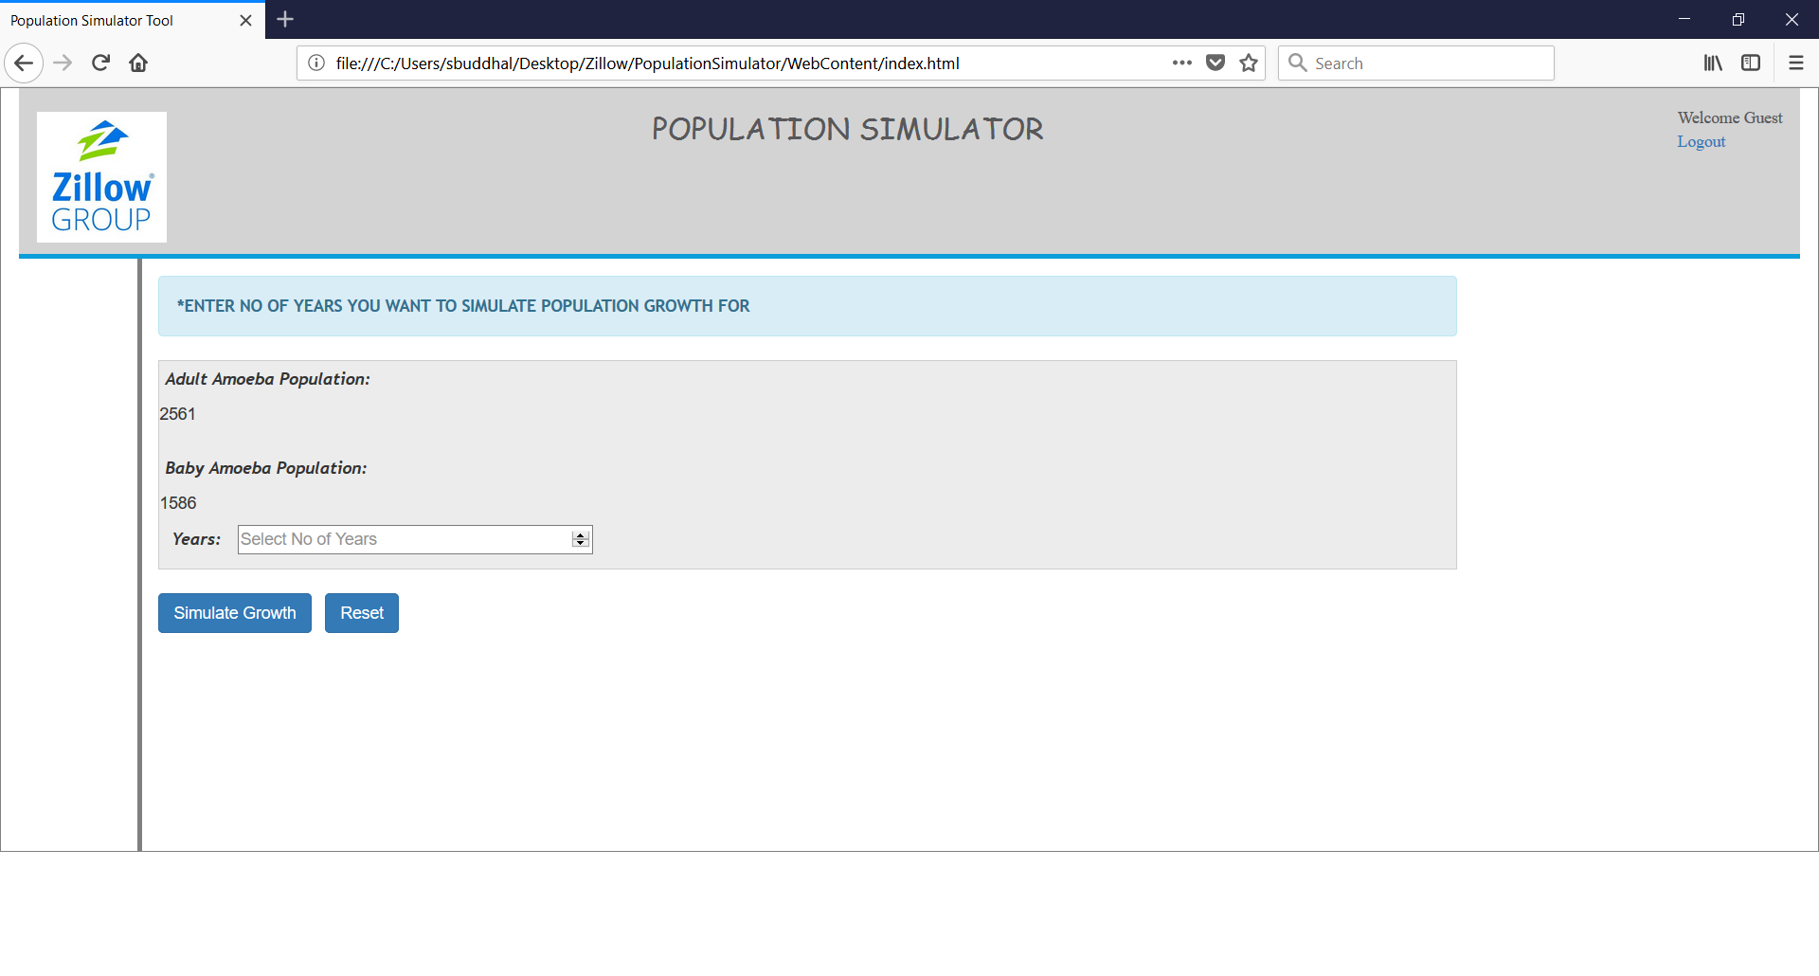

**Input**:-7 Years

**Output**: Adult population is expected to increase to 118253 from current population of 2561 after 7 years. Similarly Baby population is expected to increase to 73243 from current population of 1586 after 7 years.

